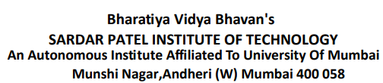

**C.I.T.L. EXPERIMENT 2**

**Submitted By:**

|  |  |
| --- | --- |
| Akash Panicker | 2021300089 |
| Mahesh Patil | 2021300095 |
| Rohit Phalke | 2021300100 |
| Adwait Purao | 2021300101 |

**Submitted To:**

Prof. Sunil Ghane

**Inventory Management System**

**Aim:**

To use the Figma tool to make wireframes for the website of inventory management systems.

**Problem Statement:**

Develop an inventory management system for a retail store that efficiently tracks and manages the inventory of products. The system should provide real-time updates on stock levels, generate alerts for low stock items, enable easy addition and removal of products, and offer insights into sales trends to optimize restocking decisions.

**Theory:**

**Introduction to User Experience (UX) Design**

UX design holds a pivotal role in shaping digital products and services. It entails a diverse range of activities aimed at crafting products that are not just functional but also delightful and user-friendly. UX design follows an iterative process, involving user needs analysis, prototyping, and rigorous testing to ensure alignment with desired objectives.

**⮚ Open Source UX Tools**

Open source UX tools have surged in popularity for various compelling reasons. They offer a cost-effective alternative to proprietary software, foster collaboration and knowledge sharing within the design community, and provide flexibility for customization to suit project-specific requirements. Prominent open source UX tools include Sketch, Figma, Inkscape, GIMP, and more. These tools empower designers to create engaging and user-centric experiences without the constraints of expensive licenses.

**Problem Definition (Multi-page Text Analysis Web Application)**

The foundation of any successful UX design project lies in a comprehensive comprehension of the underlying problem. The problem definition phase entails extensive research, stakeholder interviews, and a thorough analysis of user feedback to pinpoint pain

points and areas for improvement. A well-defined problem statement serves as the cornerstone upon which the entire design process is constructed.

**⮚ The Role of Open Source UX Tools**

Open source UX tools offer a wide array of features and functionalities tailored to different facets of the design process. These tools enable designers to craft wireframes, prototypes, mock-ups, and even facilitate usability testing. They serve as an accessible and collaborative platform for multidisciplinary teams to seamlessly collaborate.

**Why Figma?**

Figma stands out for its ability to facilitate collaboration between UX/UI designers and developers through its inspect tool. This tool empowers UX/UI designers, developers, and other collaborators to effortlessly view, modify, create, and duplicate elements, properties, and code from Figma designs. Furthermore, Figma conveniently displays code snippets in CSS, iOS, or Android formats for developers to inspect any design component. The process is simplified by merely sharing a project file link, granting developers and collaborators access to all elements, comments, prototypes, and design iterations.

**⮚ Objective of the Experiment**

The core objective of this experiment is to illustrate the effectiveness of open source UX tools in addressing a specific problem definition. By leveraging open-source software, designers can harness the capabilities of these tools to brainstorm, design, and refine solutions that elevate the user experience. This experiment will demonstrate how open source UX tools can be utilized to develop user-centred design solutions that align seamlessly with the identified problem statement.

**⮚** [**Figma Link**](https://www.figma.com/file/iA8tQXVkaeoUUn1xmtRGU2/Inventory-Management-System-Project-CITL?type=design&node-id=0-1&mode=design&t=eR08YfZJ4VPVxSKU-0)

**Screenshots:**

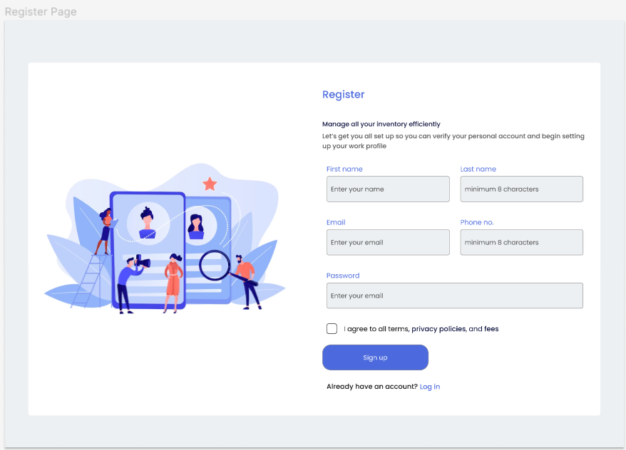

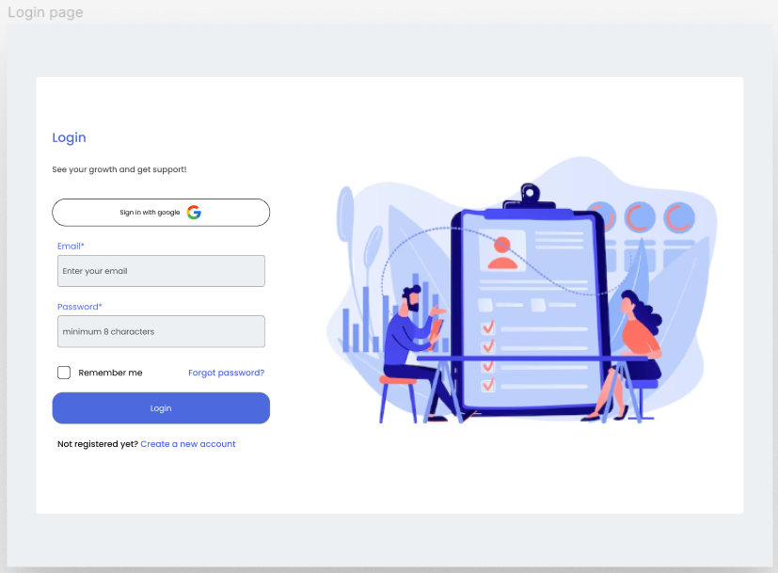

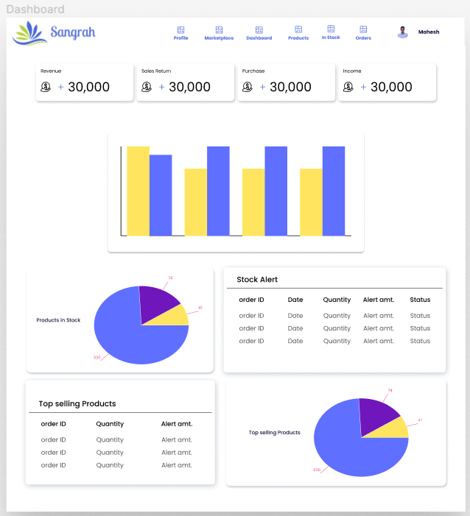

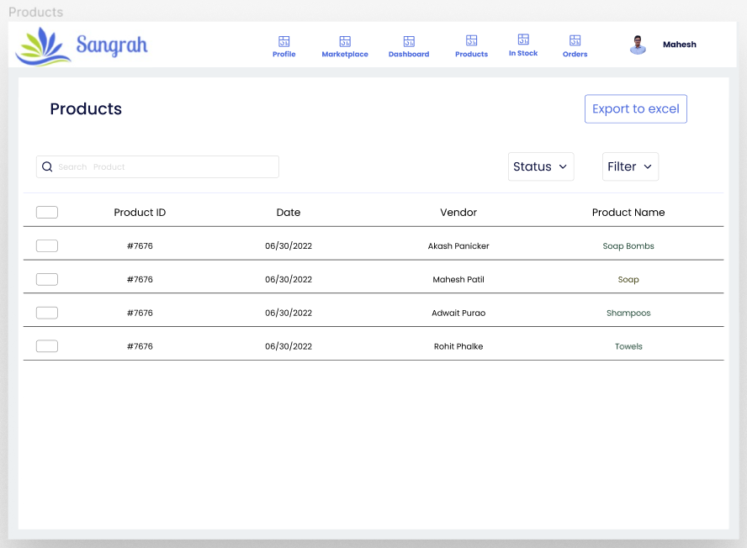

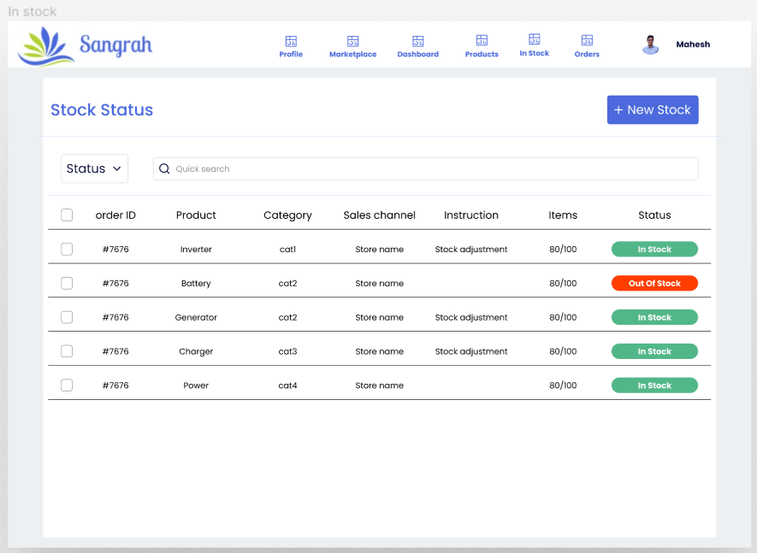

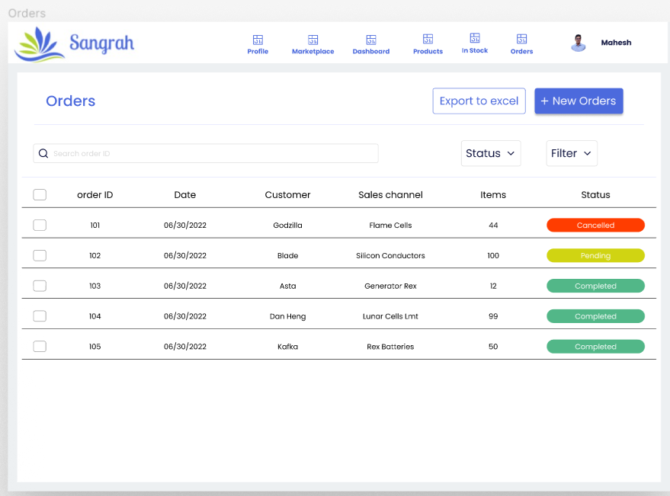

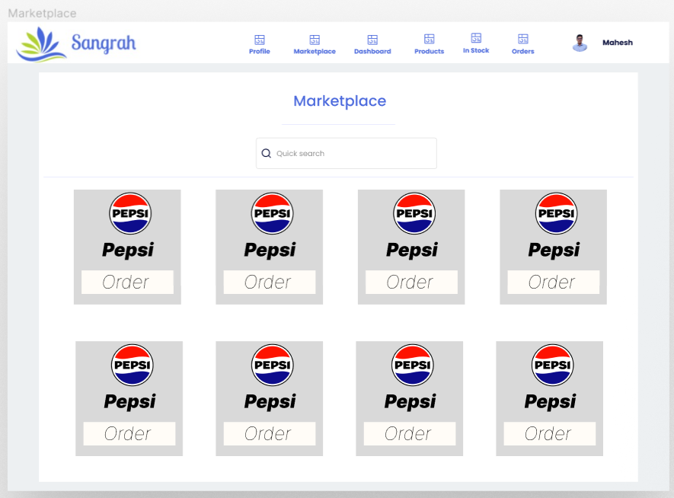

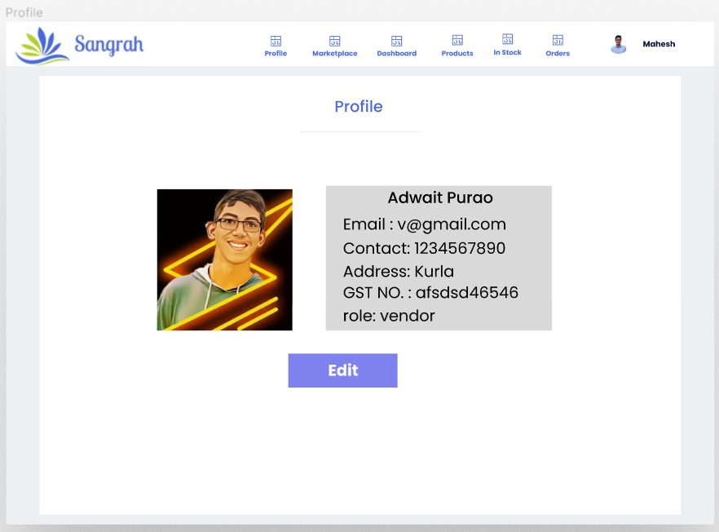

**Conclusion:**

In conclusion, this experiment seeks to highlight the capabilities of open source UX tools in tackling practical design issues. Through the utilization of these tools, designers have the ability to craft solutions that prioritize the user experience. The outcomes of this experiment will provide insights into both the benefits and constraints of open source UX tools within the realm of problem-solving and design advancement.